\

**Contact Us**

**Kowloon City Campus: 2707 3111**

**E-mail:** [**uowchk-ss@uow.edu.au**](mailto:uowchk-ss@uow.edu.au)

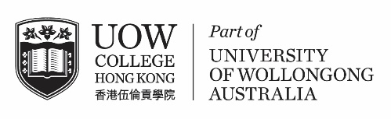**S T U D E N T**

## The Student Centre C1510

Dear students,

**Civil Service Bureau Recruitment Talk**

**Recruitment of Administrative Officer/Executive Officer II**

Civil Service Bureau (CSB) is going to launch another round of recruitment exercise for the posts of AO and EOII in around mid-September 2022. CSB will be hosting two recruitment talks for the posts respectively. Details of the talks are as follows:

**Administrative Officer Recruitment Talk**

|  |  |
| --- | --- |
| Date | 3 October 2022 (Monday) |
| Time | 10:00am to 11:00am |
| Venue | Zoom |
| Medium of Instruction | Cantonese |
| Deadline for Application | 22 September 2022 (Successful applicants will be notified by email.) |
| Link of Registration | [HERE](https://forms.gle/CUtETDaEW7qRhmYk9) |

**Executive Officer II Recruitment Talk**

|  |  |
| --- | --- |
| Date | 3 October 2022 (Monday) |
| Time | 11:00am to 12:00pm |
| Venue | Webinar |
| Medium of Instruction | Cantonese |
| Deadline for Application | 22 September 2022 (Successful applicants will be notified by email.) |
| Link of Registration | [HERE](https://forms.gle/8xNofY4TA7nQerQK6) |

During the talk, they will introduce the Officer grades, the entry requirements, the terms of appointment and fringe benefits, as well as how to apply for the posts.

Their target participants are students who are in their final year of degree programme starting in September 2022. Students successfully enrolled for the talk(s) will be advised of the webinar/Zoom details later.

The Student Centre

UOW College Hong Kong

Counselling Services &

Personal Development

**CE N T R E**