**Contact Us**

**Kowloon City Campus: 2707 3111**

**E-mail:** [**uowchk-ss@uow.edu.au**](mailto:uowchk-ss@uow.edu.au)

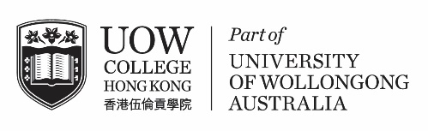**S T U D E N T**

## The Student Centre C1613

Dear students,

**Hong Kong Housing Society**

**Unleash Your Potential –Summer Internship Program**

**Hong Kong Housing Society** is organising a Summer Internship Programme for students to build business knowledge and gain valuable experience into the day-to-day operation of the Housing Society. Participants will be assigned to one of the core Business Divisions/ Sections based on students’ academic background and interest.

**Business Functions**

* Property Development
* Property Management
* Elderly Services
* Human Resources
* Finance
* Corporate Communications
* Information Technology

**Job Description**

* Attend orientation and tour visits for good understanding of overall Housing Society businesses & policies
* Attend training workshops to gain practical job related skills
* On-the-job training in one of our core business divisions to gain hands-on experience
* Assist in daily operation and clerical support
* Opportunity to collaborate with the team on different projects or ad hoc duties depending on business line’s arrangement
* Guided by experienced mentors for career advice and directions

**Requirements**

* All non-final year Degree or Non-Degree local tertiary students from any discipline
* Availability to work full-time for **8 weeks**
* Self-motivated, outgoing, energetic and a fast learner
* Excellent communication & interpersonal skill
* Fluency in spoken and written English and Chinese
* Proficiency in MS Windows application, including Excel, Word, PowerPoint & Chinese Word processing
* Passionate to develop career in property & housing industry

|  |  |
| --- | --- |
| **Internship Period** | **Deadline for Applications** |
| 17 June to 9 August 2024 (8 weeks) | On or before 31 March 2024 |

**How to apply**

Students should apply for the Summer Internship Programme through an online application to HKHS via the [website](http://www.hkhs.com/en/career-opportunities/career-opportunities).

The Student Centre  
UOW College Hong Kong

Counselling Services &

Personal Development

**CE N T R E**