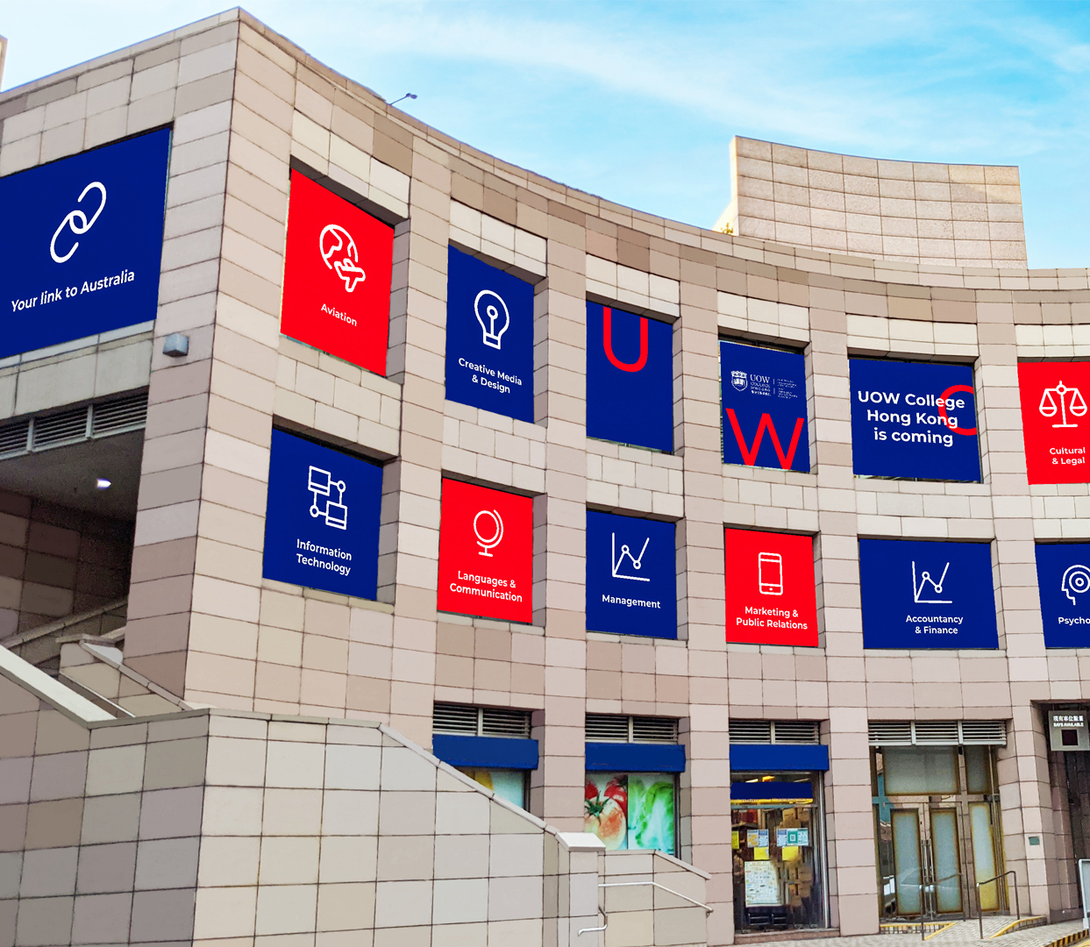
Principal Recommended Admission Scheme
校長推薦入學計劃
UOW College Hong Kong | 4/29/22 | 伍倫貢學院

Principal Recommended Admission Scheme

Objective
The Principal Recommended Admission Scheme ("the Scheme") is designed to give recognition to students who have excelled in either the academic areas and/or non-academic areas such as sports, music, the arts, or community service, or who have demonstrated leadership abilities. Quotas have been set aside for eligible candidates, and conditional offers will be made before the HKDSE examination results are released.
Under this scheme, firm offers will be issued to eligible students alongside conditional offers, regardless of their ultimate HKDSE examination results. This is intended to encourage students with exceptional, distinguished performance in academic and/or non-academic areas to study at UOWCHK.

Eligibility
Students who meet the following requirements are eligible to apply for the Scheme:
- Local students/Hong Kong residents with the right of abode;
- Associate degree, Higher Diploma and degree programme students at UOWCHK;
- Candidates who will be taking the HKDSE exam;
- Students with academic achievements;
- Students with extraordinary accomplishments in non-academic areas such as sports, music, the arts or other areas;
- Students demonstrating outstanding leadership qualities, such as Head Prefects, Presidents of Students' Union/Learning Societies; or
- Students with strong community service participation.

Submission of Application
1 All recommendations must be submitted through the SCHOOL by June 24, 2022. (Friday). Late submissions and amendments will be reviewed on a case-by-case basis. School applicants who want to be nominated for the Scheme should seek recommendations from their school principals or career masters.
2 Required documents for submission include:
- Completed School Application Form (Appendix 1) signed by the principal; and
- The student’s Personal Profile (Appendix 2) and copies of ALL certification/awards
3 Each secondary school can nominate 5 students at maximum.
4 Schools please mail or email the whole set of submission documents to:
General Office
UOW College Hong Kong, 1/F, Billionnaire Royale, 83 Sa Po Road, Kowloon City, Hong Kong
Re: “Principal Recommended Admission Scheme”
Email: uowchk-main@uow.edu.au

校長推薦入學計劃

簡介
校長推薦入學計劃（簡稱 "計劃"）旨在表揚在學術和/或非學術領域（如體育、音樂, 藝術或社區服務）表現出色的學生，或表現出領導能力的學生。該計劃為符合條件的考生預留了名額，並在香港中學文憑考試成績公佈前發出有條件錄取通知書。
無論香港中學文憑考試成績如何，我們都會通過該計劃發出正式錄取通知書，以鼓勵在學術和/或非學術領域有傑出表現的學生到香港伍倫貢學院學習。

申請資格
以下條件的學生均合資格參加本計劃：
- 擁有香港居留權的香港居民；及
- 香港伍倫貢學院副學士、高級文憑、學士學位課程的申請人；及
- 參與香港中學文憑試的在校申請人；及
- 學業成績卓越；及／或
- 在非學術領域，如體育、音樂、藝術等方面取得的非凡成就；或
- 傑出的領導能力，如領袖生、學生會/學聯會主席所具備的素質；或
- 積極參加社區服務。

遞交申請
- 請於2023年6月23日（星期五）或之前透過學校遞交申請，逾期遞交概不受理。在校申請人可經就讀學校的校長推薦參加此項計劃。
- 所需文件包括 :
- 已填妥的學校申請表(附件一)，並獲校長簽署作實
- 每位受薦學生的+個人履歷(附件二)及所有證書／獎項的副本
- 每間學校最多可推薦5位學生。
- 請校方把已填妥之申請資料一併郵寄/電郵至香港伍倫貢學院校務處。
香港九龍城沙浦道83號御豪門1樓 香港伍倫貢學院
電郵: uowchk-main@uow.edu.au
信封請註明「校長推薦入學計劃」。

